Classroom Management Plan

Bradford L Wilson Jr
(updated: 12/12/19)
Social Studies 4-8

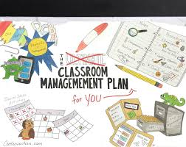

Classroom Management Plan

Procedures:
○ Arrival:
1. Students will line up quietly in the hallway outside the door in single-file line.
2. Each student will be greeted at the door by the teacher.
3. After being greeted students will quietly enter the classrooms and find their seats.
4. When seated students will review the announcements on the board and place the necessary materials on top of their desk. The remaining items must be secured under their seat, leaving the aisles clear and free of obstructions.
5. Students will begin bell ringer(s). Bell work will be done in silence (absolutely no talking above a whisper).
○ Tardy:
1. Student will knock on the door and quietly wait in the hallway outside the door.
2. If tardy is excused, place documentation in the basket matching the current period.
3. When seated student will review the announcements on the board and place the necessary materials on top of their desk. The remaining items must be secured under their seat, leaving the aisles clear and free of obstructions.
4. Student will complete bell ringer(s) at the first break.
○ Absence:
1. Copies of the day’s work will be pinned to the absence calendar.
2. To receive full credit the absence work must be completed within the number of days out the student is out of class. (for example: If the student is absent for 3 school days, the student has 3 school days to complete work)
3. To receive partial credit (maximum 70%) the absence work must be complete before the end of the current 6-weeks period.
4. Absence work must be turned into the basket of your corresponding period.
○ Homework:
No homework will be assigned in this class. Classwork will be given due dates. Group projects can be completed off campus, but time will be dedicated in class to complete them.
o Getting the Class’ Attention:
- Students will be wearing their student badges during bell work. Display your badge around your neck with picture and name facing outward.

- Name tags will be displayed on your working stations during bell work. Display your name tags with roll name facing inward.

- After bell work is complete put your name tag away. (student badges can be tucked away at this point if they impede the activities of the day)
○ Getting the Teacher's Attention:
1. For restroom use: student will raise their hand. The teacher will acknowledge the hand being raised by stating the student’s name. The student will scan out with their iPad to the bathroom and scan in at the bathroom. When returning to the classroom the student will reverse the process.
2. For questions: students will have a laminated circle on their desk. One side of the circle will be green. Students will display green when they clearly understand the assignment. One side of the circle will be red. Students will display red when they have a question on a problem. Students are expected to move on to the next problem until the teacher arrives to assist. Students will remove the circle off the desk when they are totally confused. Students will read the assigned reading for the day until the teacher arrives to assist.
○ Guidelines for Group Work:
- Have respect for the members in the group
- Respect the ideas of others
- Be willing to compromise
- Communicate effectively with the members in the group
- Ensure you cooperate
- Avoid poor time management
○ Transition (switching activities):
1. Teacher will announce “Focus” and class will respond “Focus”; Teacher will announce “on me” and class will respond “on you.”
2. Teacher will explain the procedures for preparing for the next lesson
3. Teacher will provide a signal to begin by row - the teacher will raise one hand in the air and the opposite hand will point at a row. That row will quietly begin the announced procedures.
4. Teacher observes classroom to ensure students are complying to instructions.
○ What to Do When Done
- When students are done with the current activity:
1. Quietly look around the room for students without a circle on their desk. Quietly move to the student’s desk and assist them.
2. Quietly look around the room for red circles. Quietly move to the student’s desk and assist them.
3. Look on the board and complete the current or next reading assignment.
4. Work on assignments from other periods.
5. Select a book from the class library and read quietly.
○ Dismissal
1. The bell does not dismiss the students, the teacher does.
2. A chime will be heard 1-2 minutes before the completion of class. The teacher will instruct students when to secure their items. Students will not pack their items before this notification.
3. When the bell rings all students will sit calmly in their seats until the teacher states calls your row. When the student’s row is identified they will calmly and quietly exit the classroom.
○ Bullying Pledge:
- Each student will fill out the online pledge using their iPad, screenshot the results and download the official certificate. Students will email a copy of the results and certificates to the teacher.
1. I speak up when I see bullying.
2. I reach out to others who are bullied.
3. I am a friend whenever I see bullying.
**These procedures will be recorded on a PowerPoint presentation. Each area of procedure will be practiced in groups in a Kagan structured Round Robin event. After the round robin exercise is complete the class will return to their assigned seats. Once seated the class will conduct practical exercises of the procedures.

Discipline Plan/Classroom Rules
Philosophy:
- Discipline is one of the most relative environment states in any organization. In order to make discipline transparent you must train the team or group to obey norms, written rules, and coded behavior. Enforcement comes with two responsibilities from the leader, reward desired behavior and punish undesired behavior. These responsibilities of the leader must be consistent to the point that all members of the team know what is going to happen before the act comes to fruition. The leader must be fair and honest, earning the team’s respect and building the team’s trust.
Establishing Classroom Rules:
- Classroom rules will begin with 5 mainstay rules that follow the acronym LEARN. The initial rules will outline positive expectations of behavior. Time will be provided to allow students to add guidelines and limits for behavior with an approval from their peers. If a suggestion is made and that suggestion is not covered in the main rules, it will be added and posted with the other rules.
Rules:
- Lead by example
- Ears 1st Mouth 2nd
- Always be safe
- Respect
- Never quit
Rewards:
Special seating
Homework pass
Free time
Computer (cell phone) time
Consequences:
Verbal Warning
Timeout Corner (fill out Student Accountability Form)
Note Home
Phone Call Home
Office Referral
Accountability Component:
Student Accountability Form –
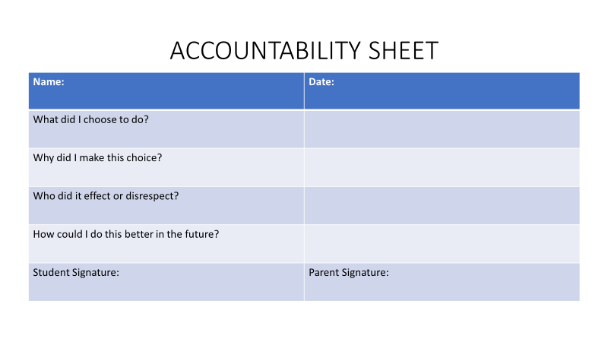
Seating:
○ Classroom with labels:
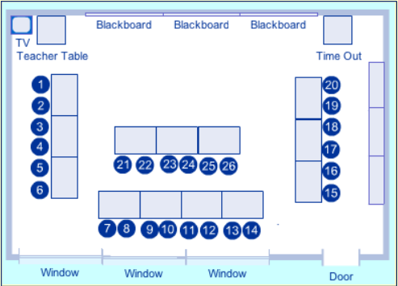

○ Seating Assignment Method:
- Written rationale:
The Modified U encourages discussion and helps facilitate independent work. Students are spaced apart causing less distraction and less side-bar discussions. A table in the center allows group work, discipline tool, or area for a Learning Center. Most importantly, it allows the instructor to utilize all the wall space in the classroom for bulletin material or learning station opportunities.
- Modified U (horseshoe); with table in the center.
- Traditional rows when testing

Preparation:
o PLANNING:
- Bulletin Board
*Bulletin board will be divided in half
- Left side: Titled Hashtagging through Histagram. 5-7 pictures of post from Social Media with hashtags of subjects and people we will discuss throughout the year. Encouraging students to fill up the board throughout the year.

- Right side: Titled What We’re Studying. 3 subtitles underneath titled: Learning Goals; Essential Questions; and Enduring Concepts

- Announcements and Calendar
- Announcements will be posted using technology (google classroom, google drive, etc.)
- Paper copy of directions on how to make an account placed on each desk
- Paper copy of announcements placed on each desk with the calendar events of the day

- Welcome Bag
- Welcome Bag placed on each desk with an item symbolizing each letter in Ldrship: (Loyalty, Duty, Respect, Selfless Service, Honor, Integrity, Personal Courage).

- Boards
- Boards will be displayed and labeled for subject area work
- Boards will be displayed for students to design
- Boards will be designated to display students’ original work

- Learning Centers
- 4 Learning stations will be established throughout the classroom labeled (Draw It, Assess It, Sort It, and Chart It) after receiving lectures.

- Supply
- Supply area will be established with common tools and resources needed to finish classroom assignments
- Students will be issued squares with their issued number to place in each bin, in place of the item they borrowed.

- Substitute Folder
- In a case marked “Break in case of Emergency” a folder containing: daily schedule, seating chart, reproducible activities
o GREETING:
- A sign above classroom door with Mr. Wilson and Room #
- The door of the classroom will have the words “About Me” posted at the top, and pictures of my life and hobbies posted around the door.
o SEATING:
- Nametags
- Each desk will have a name tag with their name (spelled exactly how it appears in the roll book on one side) and desk number. Students will have directions to write the name they would like to be called on the opposite side.
- Smaller name tags will be placed on each desk (2-3) with the student’s desk number. This tag will be placed in the bin of the borrowed supply to facilitate the items being returned.

- Take-home packet
- A packet will be placed on each desk containing:
a. Welcome message to parents
b. Emergency forms
c. Copy of school rules
d. Supply list

○ Letter of Introduction to Students
Mr. Wilson
Wilson’s Warriors Room
Social Studies
Hello,
My name Mr. Wilson and I am very excited to be your student teacher this spring. In these next few but busy months we will both learn and grow. While I will get to know each and every one of you, let me share a few things about myself.
I am a 3rd generation military brat. My grandparents and parents both served in the military. I am also a military veteran myself. I a Texas native, graduating high school in C.E. Ellison in Killeen, Texas which is in central Texas. I have 1 daughter, 1 son, and a beautiful 80 pound labradoodle named King-King (yes two-times). I spent over 20 years in the Army before deciding to pursue my dream of becoming a teacher.
I cannot wait to have a class of my own but really excited to spend the next few months with you.
Sincerely,
Mr. Wilson
○ Letter of Introduction to Parents
Dear Parents,
My name is Bradford Wilson and your son/daughter is enrolled in my social studies class this year. I am looking forward to an exciting year. It is my goal to provide all students with an exciting, yet challenging, experience in my classroom.
Social Studies can be a very demanding and controversial course. There will assignments almost daily. Each student will have a chance to finish those assignments in the classroom, and that is the expectation. Students will have the option to take home any assignments that they were not able to complete in the allotted time. The only task that will be asked to complete at home exclusively is the semester project, where your help and support is welcome. These memories will last a lifetime.
Hopefully, your son/daughter has brought home their course syllabus, both parents and students should read the syllabus and sign the syllabus contract. The syllabus is provided to ensure both parents and students understand how the course will run. Each student will need a single subject notebook, folder, a pen (black or blue ink for assignments) and pencils. These materials should be brought to class every day. If you have any questions regarding the syllabus or the course material, please contact me.
My expectations are unapologetically high for all my students. In order to reach those expectations I maintain a progressive discipline management program. The progressive steps start in the classroom and progress to communication at home, where I am asking for the parents’ help. I will also periodically ensure parents are informed of the students’ progress in the classroom. I am available to help students with progress before school, during prep periods, and after school. Please do not hesitate to contact me at the contact information below.
Thank you,
Bradford Wilson
915-667-1745
bradford.louis.wilson@gmail.com

o Tentative Agenda/Schedule for the First Day
Bell (-5 minutes): Greet each student at the door and hand them a 2-sided name tag with their name spelled exactly like the roll book on one side and blank on the other side.
- Tell each student to find a seat and place the name tag on the desk with the blank side facing out.
- Tell each student to locate the folder on their desk and do not open the folder until instructions are provided.
Bell: Welcome Speech
Welcome class. My name is Mr. Wilson and I will be your Social Studies teacher this year. Social Studies prepares young learners grow to be active, responsible and reflective members of society. Social Studies teaches you to make informed decisions because in the future all of you will have to address community, society and global concerns. This class will be very challenging and very rewarding. We will work hard, we will have fun and we will be successful.
Bell (+3 minutes): Classroom Rules.
Lead by example
Ears 1st Mouth 2nd
Always be safe
Respect
Never quit
- Explain Accountability Form
- Allow the class to suggest any rules they would like to add. Teacher will ensure the suggestion is not covered by the existing rules.
Bell (+18 minutes): Classroom Procedures
Before Entering the Classroom – Students will line-up quietly in a single file line in the hall until invited into the classroom.
Entering the Classroom – Students will enter quietly and find their seats. Take out the supplies/materials listed on the board and place all other items under the seat, ensuring aisles are clear. Review the board for announcements. Begin the bell ringer.
Getting the Teachers Attention – Students will raise their hand and make eye contact with the teacher. When the teacher has acknowledged your hand by stating your name, you will lower your hand and await the arrival of the teacher to your desk. If in a discussion and the teacher announces your name the student will then provide their relevant information to the class.
Returning assignments and supplies – At the beginning of class place your homework in the bin marked with your class period. During class items to be collected will be passed to the person in the front seat. The student in the front seat will place the items in the bin marked with the class period.
Clean up Chime – 2 minutes before the end of each class a cleanup chime will ring. This chime is an indicator to the teacher not the student. At some point after the chime engages the teacher will tell the students to clean their areas and sit down in their desk upon completion.
Class Dismissal – The teacher dismissed the class, not the bell. When the bell rings all students will sit calmly in their seats until the teacher states calls your row. When the student’s row is identified they will calmly and quietly exit the classroom.
*Class will practice dismissal. Teacher will dismiss class and ask them to line back up in the hallway and have them re-enter and execute Bell Work.
Bell (+30 minutes): Bell Work (see below)
Bell (+35 minutes): Introductions
Ok class, now it is my turn to get to know you. On the blank side of your nametag I want you to write down the name you would like to be called if it is different from your roll name. When I point to you, share your name with the class and share something unique about yourself. Finally, pick an animal that you share a quality with share with the class that animal and the quality.
Bell (+43 minutes): Clean-up Chime
Remind the class that the teacher dismisses not the bell.
Bell (+45 minutes): Dismiss class
○ First Day Bell Work Assignment
Map Activity: A world map of all countries will be provided to each student. Each map will be laminated with a hole punched in the right-hand corner. A string will be looped through each corner and tied to a dry-erase marker.
The country will be written on the board along with 5 questions. Students will be asked to find and outline the country on the map with the provided dry-erase marker. After locating the country, the following questions must be answered (issued iPad can be used to answer the questions).
- Describe (or draw the flag of the country)
- What is the capital of the country? Date of Independence?
- What countries or bodies of water border the country?
- What is the country’s climate?
- What currency (or currencies) does the country use?
*Bonus: Share any experiences you have if you have been to the country.

○ Teacher Welcome/Introduction: (original is in PowerPoint format)
